MANASES KIPRUTO SCCJ/01105/2018

**FASTSERV**

**Garage Management System**

Table of Contents

1. Overview

2. Entity Relationship Diagram

3. Flow Charts

4. Conclusion

Overview

FASTSERV is an all-in-one garage management system designed to help streamline the processes of a garage business. It provides an integrated solution to manage customer information, service orders, invoicing, inventory and more. FASTSERV is an all-in-one solution to help garages improve efficiency and maximize revenue.

FASTSERV provides comprehensive customer management, automated service order processing, invoicing, and billing, inventory tracking and management, and comprehensive reporting and analytics. With these features, garages can streamline operations, maximize revenue, improve customer satisfaction, automate tasks, and reduce manual data entry, access real-time data and insights, and reduce costs and improve profitability.

FASTSERV is the ideal solution for garages looking to take their operations to the next level. With its comprehensive suite of features, FASTSERV helps to streamline processes, maximize revenue, and improve customer satisfaction.

Features:

• Comprehensive customer management

• Automated service order processing

• Invoicing and billing

• Inventory tracking and management

• Comprehensive reporting and analytics

Benefits:

• Streamline operations and increase efficiency

• Maximize revenue by optimizing pricing and inventory control

• Improve customer satisfaction by providing personalized service

• Automate tasks and reduce manual data entry

• Access real-time data and insights to make informed decisions

• Reduce costs and improve profitability

**Flow Charts**

Flow Charts are used to illustrate the flow of data and processes within the FASTSERV system. They are used to map out the various steps and interactions that occur within the system and to identify any potential issues or bottlenecks



Login / Sign up



Type

of

vehicle,

Vehicle’s

model,

Type

of

work

it

needs

with

its

cost



Will

ask

user

the

type:

pickup or

delivery



Delivery

time

will

given

to

user



Payment

method:

cash

payment

or

online

payment



Details will be shown which will

also

be

accessible

by

user

& admin



**Figure**

Tentative Design

**Entity Relationship Diagram**

The Entity Relationship Diagram (ERD) is a visual representation of the data model used to store and manage the data within the FASTSERV system. It is used to illustrate entities, relationships and attributes. The ERD is an important tool for understanding the data structure of the system and its components.

**LOGIN**

**USER**

**ROLES**

HAS

permission

admin

Repair car

customer

car

Use case diagram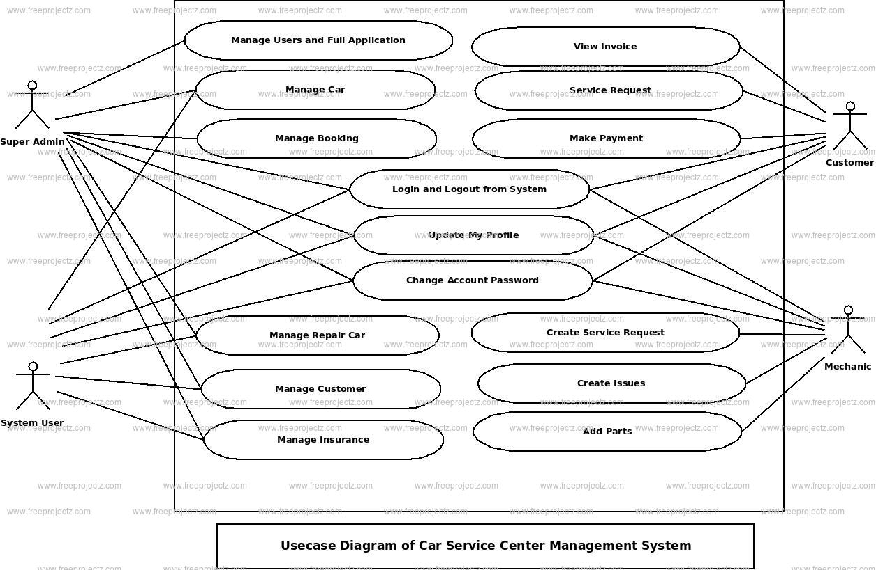

Classes: their attributes and methods

1. Car:Attributes: Brand, Model, Year, Number Plate, Owner, Insurance

Methods: Drive(), Park(), Sell(), Repair()

2. Customer:Attributes: Name, Address, Phone Number, Email

Methods: Register(), PayBill(), SubmitClaim(), ScheduleService()

3. Employee:Attributes: Name, Address, Phone Number, Email, Title

Methods: ServeCustomer(), MaintainInventory(), ProcessOrders(), UpdateDatabase()

4. Supplier:Attributes: Name, Address, Phone Number, Email

Methods: OrderParts(), ReceiveParts(), TrackInventory(), ManageInvoices()

5. Service:Attributes: Type, Cost, Duration

Methods: ScheduleService(), PerformService(), InvoiceCustomer()

6. Inventory:Attributes: Part Number, Part Name, Part Description, Quantity, Cost

Methods: CheckInventory(), OrderParts(), ReceiveParts(), TrackInventory()

7. Order:Attributes: Order Number, Customer Name, Part Number, Quantity

Methods: CreateOrder(), ProcessOrder(), TrackOrder(), UpdateDatabase()

8. Payment:Attributes: Payment Type, Amount

Methods: AcceptPayment(), ProcessPayment(), GenerateReceipt()

Conclusion

FASTSERV is a comprehensive garage management system that provides an efficient way of managing customer data, inventory, staff and other important information. The system includes a customer portal, which allows customers to book appointments and check the status of their orders. The system also includes flow charts and entity relationship diagrams, which provide a clear overview of the system’s processes and relationships. These diagrams are essential in understanding the system and ensuring its efficient operation.